**Module-2: GIT Assignment - 4**

You have been asked to:

● Put master.txt on master branch, stage and commit

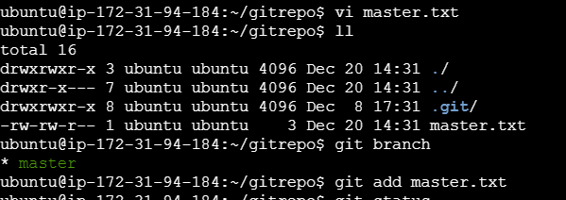

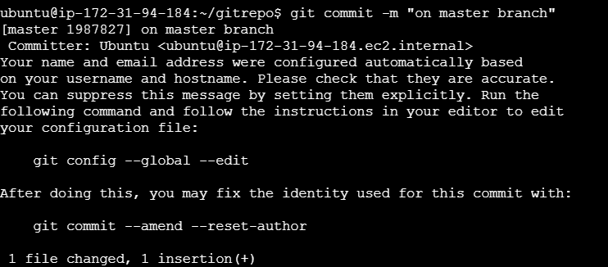

● Create 3 branches: public1, public2 and private

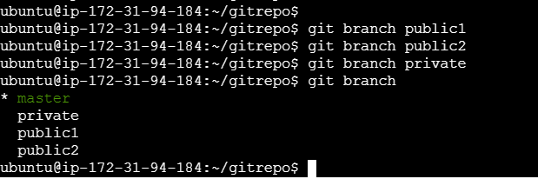

● Put public1.txt on public 1 branch, stage and commit

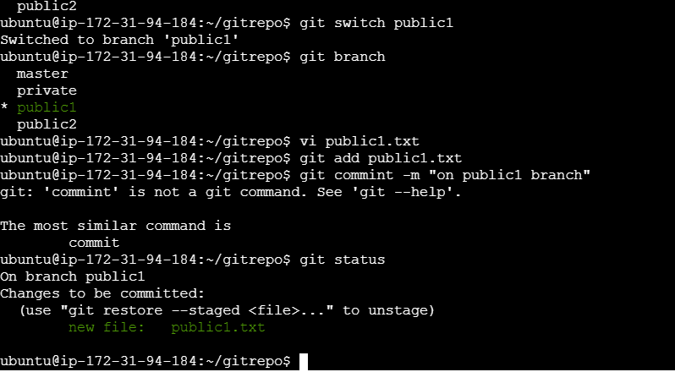

● Merge public 1 on master branch

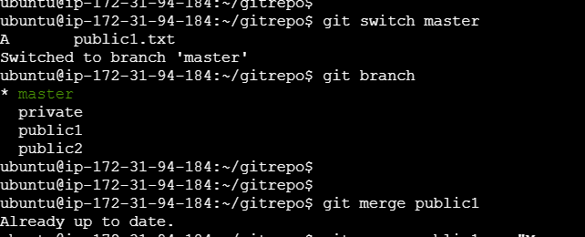

● Merge public 2 on master branch

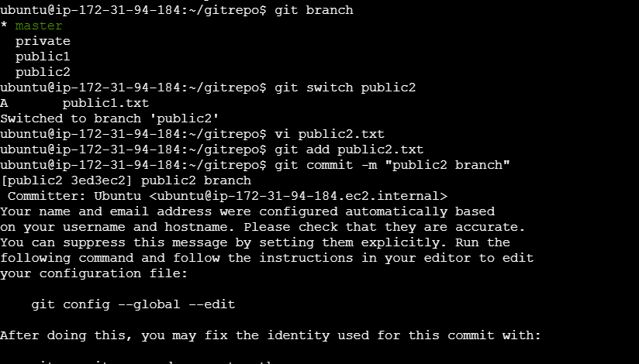

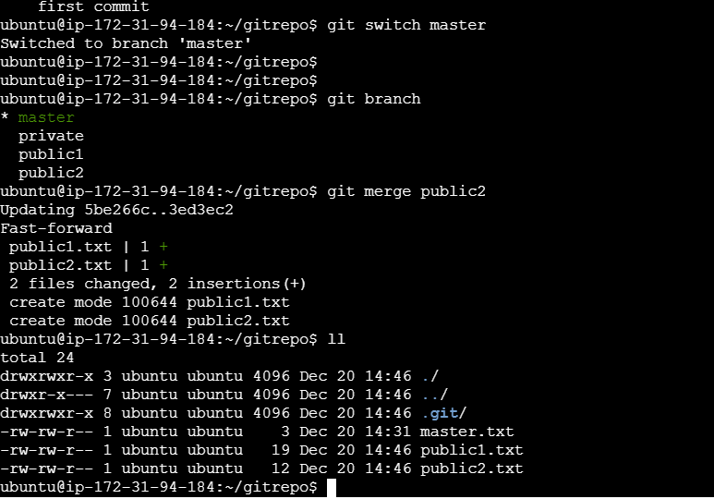

● Edit master.txt on private branch, stage and commit

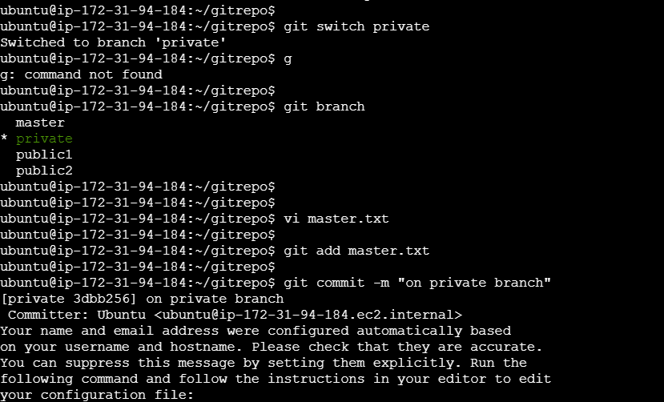

● Now update branch public 1 and public 2 with new master code in private

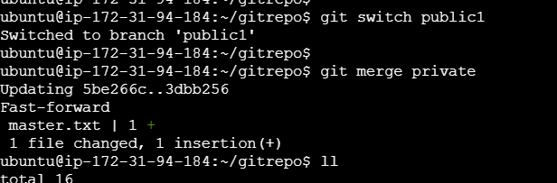



● Also update new master code on master

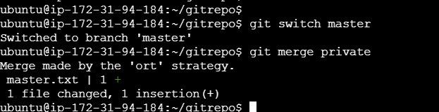

● Finally update all the code on the private branch

